Dhufish diet

Molluscs, in total, constituted approximately 5% of the dietary volume. the mollusc component of the diet of

*G. hebraicum* consisted almost entirely of cephalopods. In terms of both their volumetric contributions and frequency of

occurrence, crustaceans (comprising mainly isopods, amphipods and decapods) and

teleosts were by far the most important components of the diet of *G. hebraicum*. The Pempherididae was the most important of the

numerous identifiable teleost families ingested by both *G. hebraicum* and *E. armatus.* the volumetric contributions of small crustaceans to its

diet declined with increasing body size, whereas that of teleosts increased.

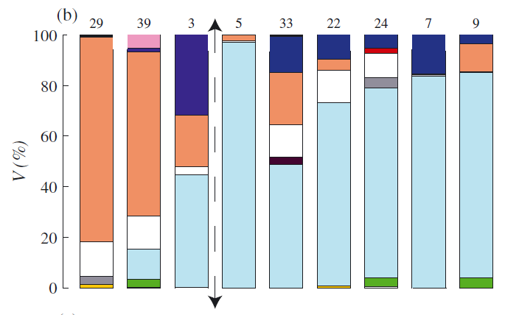

>99mm 100-199 200-299 300-399 400-499 500-599 600-699 700-799 800-899

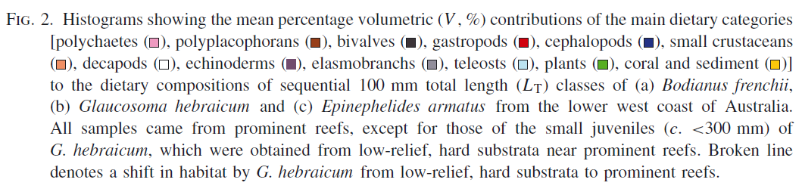

Diet of juvenile *G. hebraicum* over hard substrata was distinguished from that of this species over reefs later in life by the presence of greater volumes of small crustaceans and decapods and smaller volumes of teleosts and cephalopods.. Molluscs and echinoderms were consumed in only moderate or small amounts by *G. hebraicum.* Cephalopods was essentially the only mollusc group represented in the diet of *G. hebraicum*. Crustaceans made an important contribution to the diet of each of the three species, with decapods prominent in the diets of all three species and small crustaceans well represented in the diet of *B. frenchii* and especially of *G. hebraicum* but not of *E. armatus.* The main teleost prey of *G. hebraicum* and *E. armatus* comprised pempherids, a family of small species that is abundant over reefs in Australia. The diet of *G. hebraicum* thus undergoes a very pronounced change when this species moves from its nursery area to the habitat that it occupies for the rest of its long life, *i.e.* up to 41 years (Hesp *et al*., 2002). Once *G. hebraicum* moves to that habitat, its diet changes only slightly, reflecting the fact that, for much of adult life, teleosts are by far the most important component of its diet. *G. hebraicum* might target less active teleosts than *E. armatus* are consistent with the fact that only the former species ingests monacanthids, ophichthids and ostraciids.

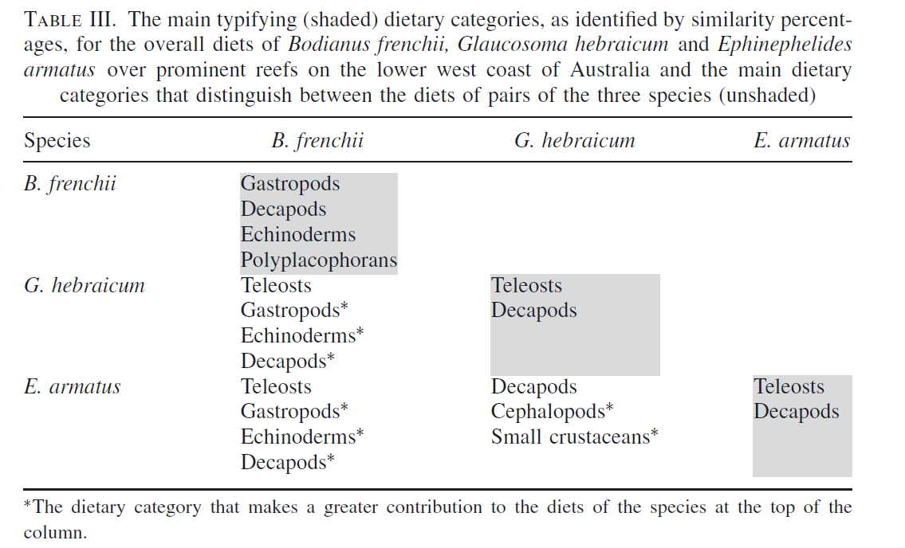

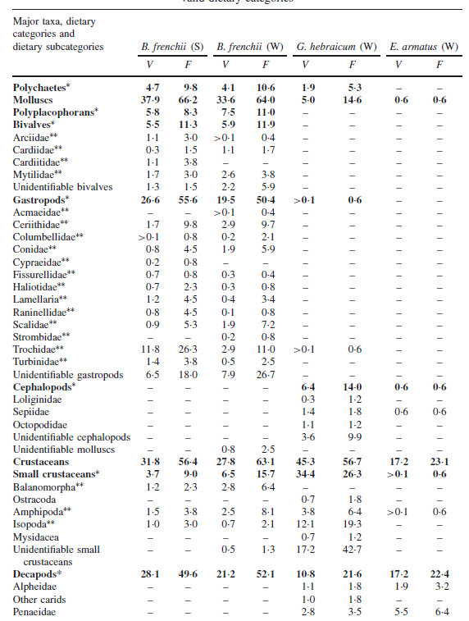

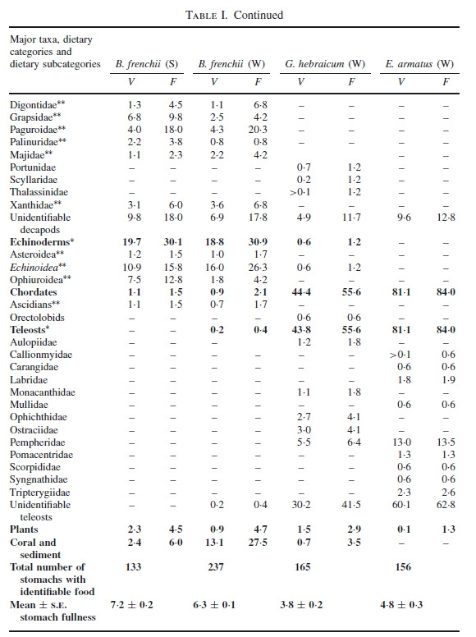

dhufish >99 mm

|  |  |
| --- | --- |
| **prey item** | **probability of consuming** |
| MAZ | 0.3 |
| FDT | 0.05 |
| FSR | 0.05 |
| BD | 0.05 |
| COR | 0.01 |
| DL | 0.01 |
| DR | 0.01 |
| BAC | 0.01 |
| CEP | 0.01 |
| BG | 0.05 |
| ZME | 0.01 |
| BFF | 0.01 |

dhufish 100-199 mm

|  |  |
| --- | --- |
| **prey item** | **probability of consuming** |
| MAZ | 0.3 |
| FDT | 0.05 |
| FSR | 0.05 |
| BD | 0.05 |
| COR | 0.01 |
| DL | 0.01 |
| DR | 0.01 |
| BAC | 0.01 |
| CEP | 0.01 |
| BG | 0.01 |
| MA | 0.02 |
| SGR | 0.02 |
| BG | 0.05 |
| ZME | 0.01 |
| BFF | 0.01 |

dhufish 200-299 mm

|  |  |
| --- | --- |
| **prey item** | **probability of consuming** |
| MAZ | 0.15 |
| FDT | 0.2 |
| FSR | 0.2 |
| BD | 0.05 |
| COR | 0.01 |
| DL | 0.01 |
| DR | 0.01 |
| BAC | 0.01 |
| CEP | 0.1 |
| BG | 0.01 |
| MA | 0.02 |
| SGR | 0.02 |
| BG | 0.05 |
| ZME | 0.01 |
| BFF | 0.01 |

dhufish 300-399 mm

|  |  |
| --- | --- |
| **prey item** | **probability of consuming** |
| FDT | 0.3 |
| FSR | 0.3 |
| SD | 0.3 |
| FPK | 0.3 |
| FDC | 0.3 |
| FDO | 0.3 |
| FMA | 0.3 |
| CEP | 0.01 |
| FSP | 0.3 |
| SAR | 0.3 |
| MAZ | 0.01 |

dhufish 400-499 mm 5

|  |  |
| --- | --- |
| **prey item** | **probability of consuming** |
| FDT | 0.3 |
| FSR | 0.3 |
| SD | 0.3 |
| FPK | 0.3 |
| FDC | 0.3 |
| FDO | 0.3 |
| FMA | 0.3 |
| FSP | 0.3 |
| SAR | 0.3 |
| BG | 0.05 |
| MAZ | 0.02 |
| CEP | 0.07 |

dhufish 500-599 mm 6

|  |  |
| --- | --- |
| **prey item** | **probability of consuming** |
| FDT | 0.3 |
| FSR | 0.3 |
| SD | 0.3 |
| FPK | 0.3 |
| FDC | 0.3 |
| FDO | 0.3 |
| FMA | 0.3 |
| FSP | 0.3 |
| SAR | 0.3 |
| BG | 0.05 |
| MAZ | 0.02 |
| CEP | 0.07 |
| DL | 0.001 |
| DR | 0.001 |
| BAC | 0.001 |

dhufish 600-699 mm 7

|  |  |
| --- | --- |
| **prey item** | **probability of consuming** |
| FDT | 0.3 |
| FSR | 0.3 |
| SD | 0.3 |
| FPK | 0.3 |
| FDC | 0.3 |
| FDO | 0.3 |
| FMA | 0.3 |
| FSP | 0.3 |
| SAR | 0.3 |
| BG | 0.05 |
| MAZ | 0.02 |
| CEP | 0.07 |
| DL | 0.001 |
| DR | 0.001 |
| BAC | 0.001 |
| MA | 0.01 |
| SGR | 0.01 |

dhufish 700-799 mm 8

|  |  |
| --- | --- |
| **prey item** | **probability of consuming** |
| FDT | 0.3 |
| FSR | 0.3 |
| SD | 0.3 |
| FPK | 0.3 |
| FDC | 0.3 |
| FDO | 0.3 |
| FMA | 0.3 |
| FSP | 0.3 |
| SAR | 0.3 |
| CEP | 0.07 |

dhufish 800-899 mm 9

|  |  |
| --- | --- |
| **prey item** | **probability of consuming** |
| FDT | 0.3 |
| FSR | 0.3 |
| SD | 0.3 |
| FPK | 0.3 |
| FDC | 0.3 |
| FDO | 0.3 |
| FMA | 0.3 |
| FSP | 0.3 |
| SAR | 0.3 |
| BG | 0.05 |
| MAZ | 0.02 |
| CEP | 0.07 |
| MA | 0.01 |
| SGR | 0.01 |

Reference:

# [Platell ME](http://www.ncbi.nlm.nih.gov/pubmed?term=Platell%20ME%5BAuthor%5D&cauthor=true&cauthor_uid=20537013), [Hesp SA](http://www.ncbi.nlm.nih.gov/pubmed?term=Hesp%20SA%5BAuthor%5D&cauthor=true&cauthor_uid=20537013), [Cossington SM](http://www.ncbi.nlm.nih.gov/pubmed?term=Cossington%20SM%5BAuthor%5D&cauthor=true&cauthor_uid=20537013), [Lek E](http://www.ncbi.nlm.nih.gov/pubmed?term=Lek%20E%5BAuthor%5D&cauthor=true&cauthor_uid=20537013), [Moore SE](http://www.ncbi.nlm.nih.gov/pubmed?term=Moore%20SE%5BAuthor%5D&cauthor=true&cauthor_uid=20537013), [Potter IC](http://www.ncbi.nlm.nih.gov/pubmed?term=Potter%20IC%5BAuthor%5D&cauthor=true&cauthor_uid=20537013).2010. Influence of selected factors on the dietary compositions of three targeted and co-occurring temperate species of reef fishes: implications for food partitioning. [J Fish Biol.](http://www.ncbi.nlm.nih.gov/pubmed/20537013) 76(6):1255-76